DKM Upgrading Switch to 4.02
Version: A
Last Edited: 9/8/2022

Approved By:

_Garrett Swindell_____________ ______Product Engineer___________
Name (Title)

CURRENT DOCUMENT STATUS
Document# | N/A
Version Number | A
File Name | DKM Upgrading Switch to 4.01
Delivery Date | Jan24-2023
Owner | Black Box Corporation
Description | Procedures

REVISION HISTORY
Revision | Version | Description of Change | Changed By | Effective Date
A |  | Initial Release | GWS | Jan24-2023

The first steps must be performed using the Java Tool 3.1.2.3 which is part of this firmware package (JavaTool_v3.1.2.3.zip). This is only available as a JAR file.

Step 1: Pre Update Step 0.1
Update your system to the provided firmware file “preStep0.1_20160329_V0301.tfw” and restart the matrix upon request of the Java Tool.

Step 2: Pre Update Step 0.2
Update your system to the provided firmware file “preStep0.2_20170622_V0304.tfw” and restart the matrix upon request of the Java Tool.

Step 3: Pre Update Step 0.3 (FPGA Update)
An update of the controller board FPGA design and the I/O board FPGA design is mandatory. For the FPGA design update in the Matrix Grid, start with the sub matrices and finally apply the update to the master matrix.

To update the FPGA design, please proceed as follows:

- Open the tab FPGA update in the Java Tool menu Status & Updates > Miscellaneous
- Press the button Browse and select the provided file “preStep0.3_DSGN.ffw”.
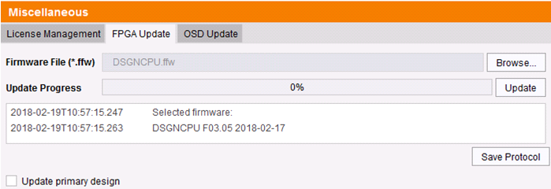

- Press the Update button

- Perform a cold start of the matrix to activate the updated FPGA design. Press the button Yes on the appearing pop-up window to shut down the matrix.

- Start your matrices. If you have a matrix grid, start your intended grid master first.

Step 4: Pre Update Step 0.4
Update your system to the provided firmware file “preStep0.4_20200506_V0308_APP.tfw” and restart the matrix upon request of the Java Tool.

Step 5: Update Step 1
Update your system to the provided firmware file “Step1_20230118_V0402_app.tfw” and restart the matrix upon request in the Java Tool.

Step 6: Update Step 2
Update your system to the provided firmware file “Step2_20221103_V0402_OSD.tfw” and restart the matrix upon request in the Java Tool.

Note: As new features and benefits are related to the firmware updated process, the latest firmware update is divided into two separate steps.

