Upgrade to 3.08 first before using this guide
DKM Upgrading Switch from 3.04 to 4.0
Version: D
Last Edited: 1/13/2022

Approved By:

_Garrett Swindell_____________ ______Product Engineer___________
Name (Title)

CURRENT DOCUMENT STATUS
Document# | N/A
Version Number | D
File Name | DKM Upgrading Switch from 3.04 to 4.0
Delivery Date | 2/11/2022
Owner | Black Box Corporation
Description | Procedures

REVISION HISTORY
Revision | Version | Description of Change | Changed By | Effective Date
B |  | Initial Release | GWS | 2/9/2021
C |  | Update to go to 3.08 first | GWS | 5/19/2021
D |  | Updated file names for newer release | GWS | 1/28/2022

BE SURE TO UPGRADE TO VERSION 3.08 before goint to 4.0! Otherwise some of your I/O cards will not get the FPGA update!

Click Here to get version 3.08

This document outlines the steps taken to update the DKM Compact or Modular switch to version 3.05 from 4.0. All steps should be done by using the latest DKM Utility (5.0.1.0 today).

Step 1: If your DKM system runs Matrix firmware older than V3.04 from June 22nd, 2017, you will have to update to the mentioned firmware first. This firmware is part of the firmware package and is named Step1_20170622_V0304.tfw.

Step 2: If the matrix already runs firmware version 03.05.180301 or newer, you can skip this step 2 Now update the FPGA (Mandatory). If you have a cascaded environment, start upgrading the Sub Matrix Switches first, then apply the update to the Main last.

- Open the tab FPGA Update in the Java Tool under Administration>>Miscellaneous.

- Press the Browse button and find the file DSGN.ffw
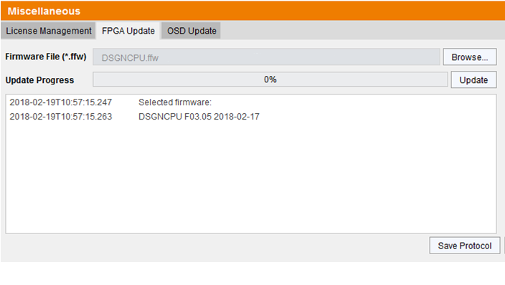
- Now press the Update button.

- Perform a cold start of the matrix to activate the updated FPGA design. Press the button YES on the appearing pop-up window to shut down the matrix.

- : Start the matrixes, if you have a matrix grid, start your intended master first

If you are below firmware 3.08, perform this step, if you are at 3.08 or above, you can skip this step.
Optional Step if using firmware older than 3.08: Update the switch using the Step2_20191018_V0308_APP.tfw Restart the matrix upon request of the DKM Utility.

Step 3: Update the switch using the Step2_20211217_V0401_APP.tfw Restart the matrix upon request of the DKM Utility.

Step 4: Finally update your system to the provided firmware file Step3_20220128_V0401_OSD.tfw Restart the matrix upon request of the DKM Utility.

Note: As new features and benefits are related to the firmware update process, the latest firmware update is divided into two separate steps.

