DKM Upgrading Switch from 3.04 to 3.05
Version: A
Last Edited: 4/24/2018

Approved By:

_Garrett Swindell_____________ ______Product Engineer___________
Name (Title)

CURRENT DOCUMENT STATUS
Document# | N/A
Version Number | A
File Name | DKM Upgrading Switch from 3.04 to 3.05
Delivery Date | N/A
Owner | Black Box Corporation
Description | Procedures

REVISION HISTORY
Revision | Version | Description of Change | Changed By | Effective Date
A |  | Initial Release | GWS | 4/24/2018

This document outlines the steps taken to update the DKM Comact or Modular switch to version 3.05 from 3.04.

You can use the files found in the folder “Design_FPGA-Update”.

Step 1: If your DKM system runs Matrix firmware older than V3.04 from June 22nd, 2017, you will have to update to the mentioned firmware first. This firmware is part of the firmware package and is named “Step1_20170622_V0304.tfw”.

Step 2: Update the FPGA design by launching the new 3.5.5.3 DKM Java Utility, and going to Administration>>Miscellaneous>>FPGA Update, and selecting the DSGNCPU.ffw file for the FPGA design for the Controller Board. Make sure the “Update Primary Design” is unchecked for the first update.

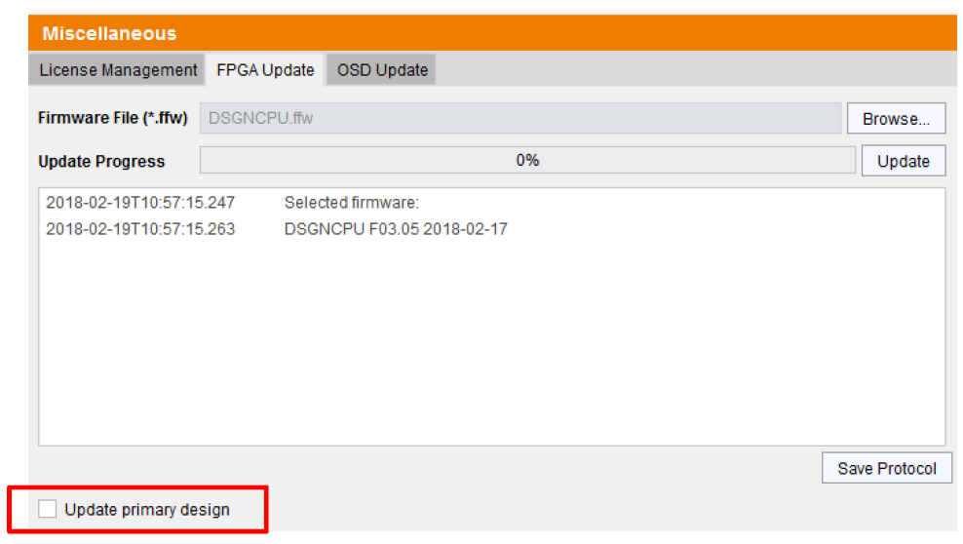

Step 3: After the update a pop-up window will appear asking to restart the switch, select NO and go to the next step.

Step 4: Repeat Step 2, but check the box “Update Primary Design”. This will be the second update, but with the Update Primary Design box checked.
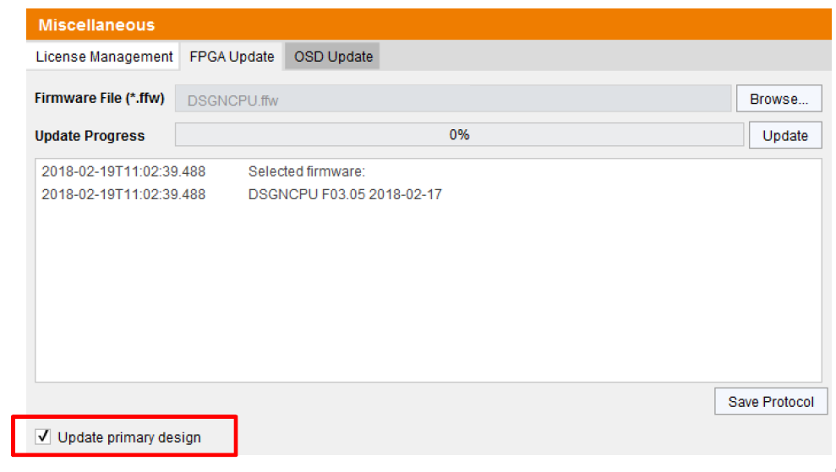

Step 5: After the update a pop-up window will appear asking to restart the switch, select NO and go to the next step.

Step 6: Now repeat Steps 2 through 5 again with the file name “DSGNIO8V2.ffw”, same method with doing the dual-update.

Step 7: Perform a cold start of the matrix to activate the updated FPGA designs. Press the button YES on the appearing pop-up window to shut down the matrix.

Step 8: Start your Matrixes. If you have a matrix grid, start your intended grid master first.

Step 9: Finally, update your system using the provided “Step2_20180301_V0305.tfw”

